**Assignment 6 – Part 1  
Assignment: Set 5.6 : 2 , 4 & Set 5.7: 4, 6, 7**







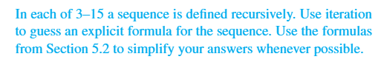

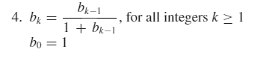 **Guess: $$b_{n}=\frac{1}{n+1}$$**

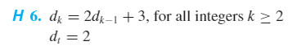 $$d_{t+1}=2⋅2+3=2^{2}+1⋅3 \\ d_{t+2}=2⋅\left(2⋅2+3\right)+3=2^{3}+3⋅3 \\ d_{t+3}=2⋅\left(2^{3}+3⋅3\right)+3=2^{4}+7⋅3 \\ d_{t+4}=2⋅\left(2^{4}+7⋅3\right)+3=2^{5}+15⋅3$$**Guess: $$d_{n}=2^{n}+{3(2}^{n-1}-1)$$**

$$e_{1}=4⋅2+5 \\ e_{2}=4\left(4⋅2+5\right)+5=16⋅2+5⋅5 \\ e_{3}=4\left(16⋅2+5⋅5\right)+5=64⋅2+21⋅5 \\ e_{4}=4\left(64⋅2+21⋅5\right)+5=256⋅2+85⋅5$$**Guess: $$e_{n}=4^{n}⋅2+(4^{n-1}+4^{n-2}+…+4^{0})⋅5$$**